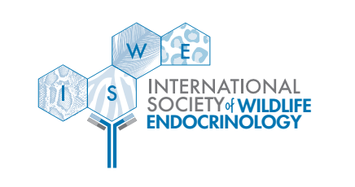
8th Annual Meeting of the
International Society of Wildlife Endocrinology
November 6th – 10th, 2023
Jim Corbett National Park, India
Hosted by:
Ahmedabad University, Ahmedabad
Center for Cellular & Molecular Biology, Hyderabad
Wildlife Institute of India, Dehradun

Travel Grant Application

Dear Students!
We are delighted to announce that graduate (MS, MA, PhD) and postdoctoral students with outstanding contributions have the opportunity to apply for a travel grant to attend the 8th Conference of the International Society of Wildlife Endocrinology!

The travel grant will cover the costs of expenses to attend the conference up to a total of $1,500 USD.

To apply, please complete the TRAVEL GRANT APPLICATION below and send it and a copy of your abstract to: lara.metrione@sezarc.com

DEADLINE FOR TRAVEL GRANT REQUEST: June 22nd, 2023
Notifications of awards will be given approximately by June 29th, 2023.

Please note: You must still submit your ABSTRACT via the online submission system for general conference acceptance by April 29th, 2023. You will then send in a copy of your abstract with the travel grant application. Awardees will be asked to provide a photograph and a one-paragraph biography to post on the ISWE website.

PREVIOUS GRANT TESTIMONIALS

The student travel grants offered me the opportunity to learn about innovative ideas and novel research areas by the hand of experienced investigators from around the world!
--Annaïs Carbajal, Coralie Munro Memorial Travel Scholar

The Arbor Assays travel scholarship allowed me to present my work and myself to international leaders in the field of wildlife endocrinology, opening the doors for mentoring and collaboration.
--Dr. Lara Metrione, Arbor Assays Travel Scholar

I was in the midst of my PhD research when I was given the opportunity to present my preliminary findings on Asian elephants in Malaysia to leading experts in the field, young researchers and endocrinologists from all over the world. The ISWE conference is a wonderful platform for young researchers to learn from veterans and from each other; not to mention, to build up your professional network. If you are working on wildlife endocrinology and have something interesting to share, I would highly recommend for you to participate in the ISWE conference and apply for their travel grants.
--Dr. Wong Ee Phin, Kingfisher International Travel Scholar

It gave me the opportunity to interact with world-renowned researchers in the field of wildlife endocrinology, where I could share ideas and build valuable collaborations.
--Dr. Juan Scheun, Arbor Assays Travel Scholar

8th Annual Meeting of the
International Society of Wildlife Endocrinology
November 6th – 10th, 2023
Jim Corbett National Park, India
Hosted by:
Ahmedabad University, Ahmedabad
Center for Cellular & Molecular Biology, Hyderabad
Wildlife Institute of India, Dehradun

Full Name:

Institution:

Email address:
Mailing address:
Phone number:

Are you an ISWE member?

Do you currently live in a country categorized as an emerging nation by the UN (p.154)?

Your abstract title:

Please describe how attending the ISWE conference could help you to achieve your career goals
(max. 300 words):

Please complete the budget table of expenses below to estimate your cost to attend the conference (if a category is not applicable, write “NA”).
Category | Calculation | Total
Airfare | $ × 1 round-trip
Fuel (if driving) | mi × gal/mi × $/gal
Lodging | $ × nights
Meals | $/meal × meals/day × days
GRAND TOTAL

