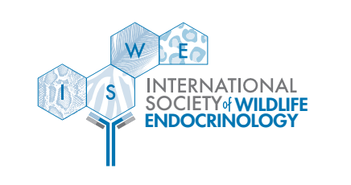
8th Annual Meeting of the
International Society of Wildlife Endocrinology
November 6th – 10th, 2023
Jim Corbett National Park, India

Hosted by:
Ahmedabad University, Ahmedabad
Center for Cellular & Molecular Biology, Hyderabad
Wildlife Institute of India, Dehradun

Arbor Assays Conference Registration Award Application

Dear Endocrine Lab Technicians and Managers!

We are delighted to announce a new award for endocrine lab technicians and managers with outstanding contributions to research presented at the conference. Arbor Assays is sponsoring a Conference Registration Award for free registration to the 8th Conference of the International Society of Wildlife Endocrinology!

We recognize the critical role you play in supporting research and advancing the field of wildlife endocrinology. However, we also know that there are limited opportunities to secure funding for conferences. Whether you are presenting your own research or have contributed to research that someone else is presenting, we would like to help you attend the upcoming ISWE conference.

Eligibility
- You must be working as a technician or lab manager in an endocrinology lab. Both part-time and full-time employees are eligible.
- You must have contributed to work being presented at the 8th Conference of the International Society of Wildlife Endocrinology. You may present your own work, but you are not required to give a presentation.
- You must not be eligible for the student grants (i.e., not conducting post-graduate research).

Award
- This award will cover the total cost of conference registration.

Application
- To apply, please complete the CONFERENCE REGISTRATION AWARD APPLICATION below and send it to: k.fanson@latrobe.edu.au

DEADLINE FOR THE CONFERENCE REGISTRATION AWARD REQUEST:
- Friday, June 30th, 2023 by midnight Alaska Standard Time
- Notification of award will be given no later than July 15th, 2023

Do not hesitate to contact Kerry Fanson at k.fanson@latrobe.edu.au if you have any questions!
8th Annual Meeting of the
International Society of Wildlife Endocrinology
November 6th – 10th, 2023
Jim Corbett National Park, India

Hosted by:
Ahmedabad University, Ahmedabad
Center for Cellular & Molecular Biology, Hyderabad
Wildlife Institute of India, Dehradun

Arbor Assays Conference Registration Award Application

Full Name:

Lab Name & Institution:

Do you currently work in a country categorized as an emerging nation by the UN?
Position:

Email address:

Mailing address:

Phone number:

Are you an ISWE member?

Are you eligible for the student grants?

What percentage of your work is related to endocrinology?

Describe your contribution(s) to research being presented at the conference. Please include the title(s) and name of the presenting author(s). (max. 200 words)

What is one contribution you have made to the lab that you are most proud of? This may be research-related, but it may be contributing to lab culture or improving workflow, etc. (max. 200 words)

Explain how attending the ISWE conference contributes to your career goals. (max. 200 words)

Attach a photo of you doing something crazy or unexpected in the name of science, with a brief explanation.

